Unit Services
Chapter
5
Structural engineering problems always have a system of units associated with them. This is due to the fact that these sorts of problems are associated with tangible and measurable entities. Fortunately, most engineering problems can be solved using a set of consistent units.
Input to engineering problems do not often appear in a consistent set of units. The unit of measure is influenced by magnitude of the item being measured and customary unit systems. For example, large distances may be measured in feet while shorter distances may be measured in inches. If we were working in Europe, distances would be measured in meters and millimeters. To work in consistent units, one of the distances must be converted to the units of measure of the other (feet to inches or inches to feet). This is where the unit conversion services come into play. This package provides generalized services for unit conversions.
During the solution of many structural engineering problems, a specification such as the AASHTO LRFD Bridge Design Specification, must be consulted. Specifications contain equations that must be evaluated. These equations are typically unit-dependent. That is, the input variables must conform to a specified set of units, and the output of the equation is in a specified set of units. Adhering to the unit consistent design philosophy of the WBFL, the inputs and outputs of unit dependent equations are in consistent units. In order for the WBFL to properly evaluate the code equations, it must know what the consistent units are. This is where the System Units service comes into play. At application startup, a set of consistent units can be specified. When ever the WBFL evaluates a unit-dependent equation, the proper conversions can be made.
It is common in civil engineering projects to represent the distance along an alignment with stations. In traditional English units stations are in hundreds of feet. In SI units stations are in thousands of meters. The stationing services provides a mechanism to represent a length in station format and to convert a station to a floating point number. Stations in English units take for form xxx+yy.zz and stations in SI units take the form xxx+yyy.zzz.
Figure 1 shows the general relationship between the various unit services components.
Figure 1
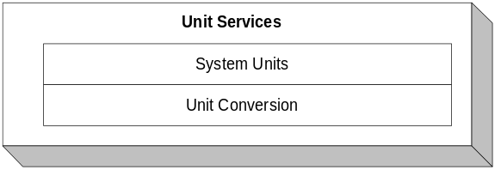

Unit Conversions
The WBFL uses floating point number when representing quantities with physical units such as length, force, and moment. There are implied units of measure associated with these physical quantities such as meter, Newton, and Newton-meters. The unit conversion system provides a general method for converting the units of measure of floating point values. For example, a length measured in meters can be easily converted to a length measured in feet.

Definitions
Physical Unit | Measure of an attribute of a physical entity such as length or time.
Unit of Measure | Type of measure of a physical unit such as feet or inches for the physical unit length.

Requirements

General
The unit conversion system must provide a typesafe mechanism for converting between units of measure for the physical units defined in this specification and those created extensions to the units conversion system.

Physical Units
The unit conversion system must support the following physical units.
- Mass
- Length
- Length²
- Length³
- Length⁴
- Time
- Temperature
- Angle
- Pressure
- Unit Weight
- Density
- Force
- Force per Length
- Moment
Third party developers must be able to create user defined physical unit types at compile time.

Units of Measure
The following units of measure must be provided.
Physical Unit | Units of Measure
Mass | gram, kilogram, slug, pound mass
Length | feet, inch, yard, mile, meter, kilometer, millimeter, and centimeter
Length² | feet², inch², yard², mile², meter², kilometer², millimeter², and centimeter²
Length³ | feet³, inch³, yard³, mile³, meter³, kilometer³, millimeter³, and centimeter³
Length⁴ | feet⁴, inch⁴, yard⁴, mile⁴, meter⁴, kilometer⁴, millimeter⁴, and centimeter⁴
Time | second, minute, hour, day, year
Temperature | Fahrenheit, Centigrade
Angle | degree, radian
Pressure | psi, ksi, psf, ksf, Pa, kPa, MPa
Unit Weight | pcf, pci, N/m³
Density | lbm/ft³, kg/m³
Force | pound, kip, ton, Newton, Kilonewton, metric ton
Force per Length | lb/ft, lb/in, kip/ft, kip/in, N/m, N/mm
Moment | k-ft, k-in, ft-lbs, in-lbs, N-m, kN-m
Units of measure must be extensible by WBFL clients.

Logical Design
The unit conversion system consists of a physical unit class template, instantiations of the template, a unit of measure utility class, and a unit conversion template method. The template class unitPhysical captures the common implementation of all physical units. unitPhysical is instantiated for the physical unit types defined in this specification. The unit of measure associated with each physical unit type is encapsulated in the class unitMeasure. This class defines constants for units of measure such as feet and inches. Unit conversions are handled by the template method Convert.
The template class unitPhysical provides the common implementation for all physical unit types. The implementation captures the notion of a conversion factor and a unit tag. Unit conversion factors will be discussed in detail later. A unit tag is a simple text string that can be used to identify the unit of measure when displaying a united value. The template arguments of unitPhysical define the exponent for the various aspects of a physical unit’s dimensionality. unitPhysical has five template arguments, mass, length, time, temperature, and angle. The template arguments provide a notational mechanism for instantiating the template and define the dimensionality of the physical unit. The instantation of an instantiated unitPhysical template represents a unit of measure.
The physical unit class is instantiated to create the physical unit types defined in this specification. The template arguments used in the instantiation define the dimensionality of the physical unit type. As an example consider the physical unit force. Force is a compound unit derived from mass and acceleration. Acceleration is a compound unit derived from length and time. The dimensionality of force is (mass¹)(length¹)(time⁻²) so the instantiated unitPhyscial template is unitPhysical<1,1,-2,0,0>. This verbose class name is typedefed to unitForce for convenience.
The class unitMeasure encapsulates units of measure for the various physical unit types. For each unit of measure, unitMeasure defines a constant data member that holds the conversion factors and unit tag for that unit of measure. Clients of the Unit Services package are free to use the units of measure defined in unitMeasure or they can defined their own as needed.
Units are converted using a template method named Convert. This method is parameterized with a single physical unit type so that is can be both physical unit specific and typesafe. Compile time errors will occur if a conversion using mismatched physical unit types is attempted. The unit conversion is performed using 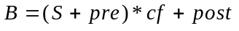 and 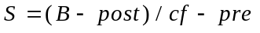where B is the converted value in a base unit common to all the conversion factors (not to be confused with internal base units), S is a floating point value in a specified unit, pre is a pre-addition parameter, cf is a conversion factor, and post is a post-addition parameter.

Static Models
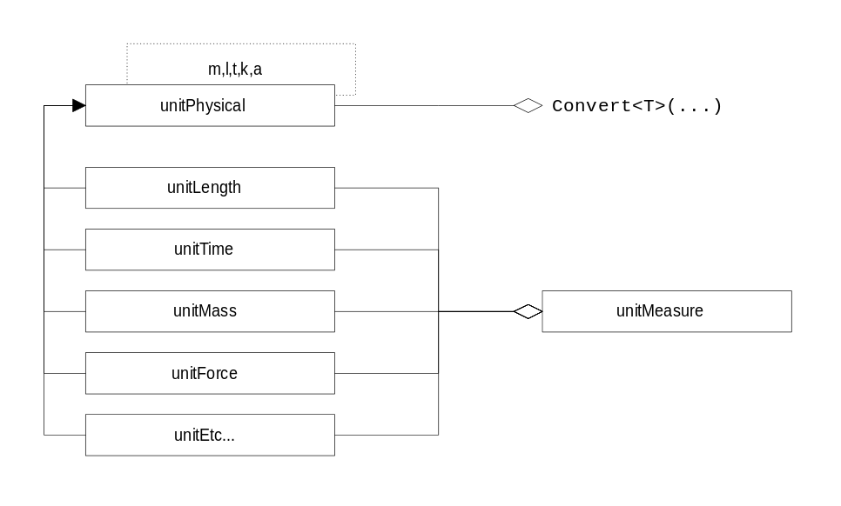
Figure 2

Dynamic Models

Using Unit Conversion services
The following code snippet illustrates the usage of the units conversion services.
// Convert feet to meters
Float64 feet_value = 1.0;
Float64 meter_value= Convert( feet_value,
unitMeasure::Feet,
unitMeasure::Meter);
// Create unit of measure at runtime
unitLength yard(0.00,3.00,0.00,”yd”);
Float64 yard_value = Convert( meter_value, unitMeasure::Meter, yard);
// Create your own physical unit type and units of measure for that type
typedef unitPhysical<1,1,-3,0,0> unitForcePerTime;
unitForcePerTime kips_per_sec(0.00,1.00,0.00,”k/s”);
unitForcePerTime lbf_per_sec(0.00,0.0001,0.00,”lbf/s”);
Float64 kps_value = 1.;
Float64 pps_value = Convert( kps_value, kips_per_sec, lbf_per_sec );

Initializing System Units
The following sequence diagram shows how the System Units might be initialized.
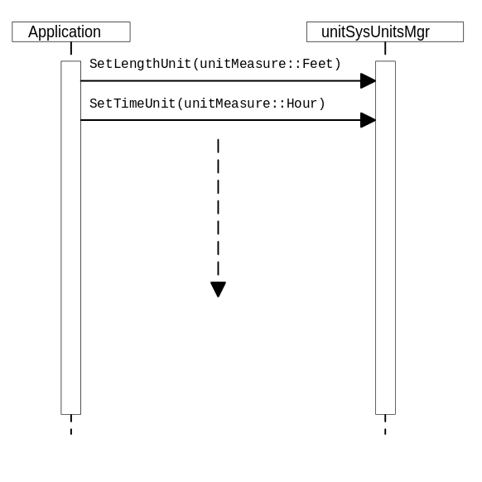

Physical Design
Figure 3
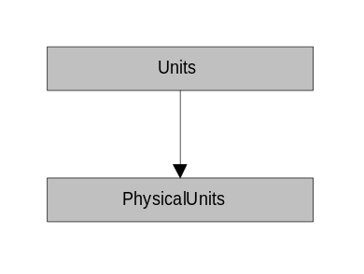
Component | Classes in Component
PhysicalUnits | unitPhysical<m,l,t,k,a> and all instantiations.  Convert<T>
Units | unitMeasure
The units of measure constants defined in unitMeasure are placed in a separate physical component to allow them not to be used.
Physical design metrics are omitted in this package because they wont be very meaningful.

Specifications

template <int m, int l, int t, int k, int a> unitPhysical
A template class representing a physical unit. A physical unit defines a unit of measure like length or time.

Public Interface - Member Functions
unitPhysical
unitPhysical(Float64 pre, Float64 cf, Float64 post, const std::string& tag);
Constructor
unitPhysical
unitPhysical(const unitPhysical& rOther);
Copy constructor
operator=
unitPhysical& operator=(const unitPhysical& rOther);
Assignment operator
PreTerm
Float64 PreTerm() const;
Returns the pre-addition term.
ConvFactor
Float64 ConvFactor() const;
Returns the conversion factor.
PostTerm
Float64 PostTerm() const;
Returns the post addition term.
UnitTag
std::string UnitTag() const;
Returns the unit tag.

unitPhysical<1,0,0,0,0> (unitMass)
An instantiation of unitPhysical that represents mass units. A typedef name for this physical unit type is shown in parentheses.

unitPhysical<0,1,0,0,0> (unitLength)
An instantiation of unitPhysical that represents length units.

unitPhysical<0,3,0,0,0> (unitLength2)
An instantiation of unitPhysical that represents area units.

unitPhysical<0,3,0,0,0> (unitLength3)
An instantiation of unitPhysical that represents volume and section modulus units.

unitPhysical<0,4,0,0,0> (unitLength4)
An instantiation of unitPhysical that represents moment of inertia units.

unitPhysical<0,0,1,0,0> (unitTime)
An instantiation of unitPhysical that represents time units.

unitPhysical<0,0,0,1,0> (unitTemperature)
An instantiation of unitPhysical that represents temperature units.

unitPhysical<0,0,0,0,1> (unitAngle)
An instantiation of unitPhysical that represents angular units.

unitPhysical<1,-1,-2,0,0> (unitPressure, unitStress)
An instantiation of unitPhysical that represents pressure and stress units.

unitPhysical<1,-3,-3,0,0> (unitUnitWeight)
An instantiation of unitPhysical that represents unit weight units.

unitPhysical<1,-3,0,0,0> (unitDensity)
An instantiation of unitPhysical that represents density units.

unitPhysical<1,1,-2,0,0> (unitForce)
An instantiation of unitPhysical that represents force units.

unitPhysical<1,0,-2,0,0> (unitForcePerLength)
An instantiation of unitPhysical that represents force per length units.

unitPhysical<1,2,-2,0,0> (unitMoment)
An instantiation of unitPhysical that represents moment units.

unitMeasure
Encapsulates the instantation of physical unit object. This is a utility class that contains only public static constant data members. To improve readability, the ms_ prefix has been omitted. Need to work out conversion factors in the table below.
Signature | Pre-term | Multiplier | Post-term | Tag
static const unitMass Kilogram; | 0.0 | 1.0 | 0.0 | kg
static const unitMass Gram; | 0.0 | 0.001 | 0.0 | g
static const unitMass Slug; |  |  |  | slug
static const unitMass PoundMass; |  |  |  | lbm
static const unitLength Feet |  |  |  | ft
static const unitLength Inch |  |  |  | in
static const unitLength Yard |  |  |  | yd
static const unitLength Mile |  |  |  | mile
static const unitLength Meter |  |  |  | m
static const unitLength Kilometer |  |  |  | km
static const unitLength Millimeter |  |  |  | mm
static const unitLength Centimeter |  |  |  | cm
static const unitLength2 Feet2 |  |  |  | ft^2
static const unitLength2 Inch2 |  |  |  | in^2
static const unitLength2 Yard2 |  |  |  | yd^2
static const unitLength2 Mile2 |  |  |  | mile^2
static const unitLength2 Meter2 |  |  |  | m^2
static const unitLength2 Kilometer2 |  |  |  | km^2
static const unitLength2 Millimeter2 |  |  |  | mm^2
static const unitLength2 Centimeter2 |  |  |  | cm^2
static const unitLength3 Feet3 |  |  |  | ft^3
static const unitLength3 Inch3 |  |  |  | in^3
static const unitLength3 Yard3 |  |  |  | yd^3
static const unitLength3 Mile3 |  |  |  | mile^3
static const unitLength3 Meter3 |  |  |  | m^3
static const unitLength3 Kilometer3 |  |  |  | km^3
static const unitLength3 Millimeter3 |  |  |  | mm^3
static const unitLength3 Centimeter3 |  |  |  | cm^3
static const unitLength4 Feet4 |  |  |  | ft^4
static const unitLength4 Inch4 |  |  |  | in^4
static const unitLength4 Yard4 |  |  |  | yd^4
static const unitLength4 Mile4 |  |  |  | mile^4
static const unitLength4 Meter4 |  |  |  | m^4
static const unitLength4 Kilometer4 |  |  |  | km^4
static const unitLength4 Millimeter4 |  |  |  | mm^4
static const unitLength4 Centimeter4 |  |  |  | cm^4
static const unitTime Second | 0.0 | 1.0 | 0.0 | sec
static const unitTime Minute | 0.0 |  | 0.0 | min
static const unitTime Hour | 0.0 |  | 0.0 | hr
static const unitTime Day | 0.0 |  | 0.0 | day
static const unitTemperature Fahrenheit |  |  |  | F
static const unitTemperature Centigrade |  |  |  | C
static const unitAngle Degree |  |  |  | deg
static const unitAngle Radian |  |  |  | rad
static const unitPressure PSI |  |  |  | psi
static const unitPressure KSI |  |  |  | ksi
static const unitPressure PSF |  |  |  | psf
static const unitPressure KSF |  |  |  | ksf
static const unitPressure Pa |  |  |  | Pa
static const unitPressure kPa |  |  |  | kPa
static const unitPressure MPa |  |  |  | MPa
static const unitUnitWeight PCF |  |  |  | pcf
static const unitUnitWeight PCI |  |  |  | pci
static const unitUnitWeight NewtonPerMeter3 |  |  |  | N/m^3
static const unitDensity LbmPerFeet3 |  |  |  | lbm/ft^3
static const unitDensity KgPerMeter3 |  |  |  | kg/m^3
static const unitForce Pound |  |  |  | lbf
static const unitForce Kip |  |  |  | kip
static const unitForce Ton |  |  |  | ton
static const unitForce Newton |  |  |  | N
static const unitForce Kilonewton |  |  |  | kN
static const unitForce MetricTon |  |  |  | metric ton
static const unitForcePerLength LbfPerFoot |  |  |  | ppf
static const unitForcePerLength LbfPerInch |  |  |  | ppi
static const unitForcePerLength KipPerFoot |  |  |  | kpf
static const unitForcePerLength KipPerInch |  |  |  | kpi
static const unitForcePerLength NewtonPerMeter |  |  |  | N/m
static const unitForcePerLength NewtonPerMillimeter |  |  |  | N/mm
static const unitMoment KipFeet |  |  |  | k-ft
static const unitMoment KipInch |  |  |  | k-in
static const unitMoment FtLbf |  |  |  | ft-lbf
static const unitMoment InchLbf |  |  |  | in-lbf
static const unitMoment NewtonMeter |  |  |  | N-m
static const unitMoment KilonewtonMeter |  |  |  | kN-m

Implementation Notes
This class is implemented as shown here.
Header File - Declare the units of measure
class UNITCLASS unitMeasure
{
public:
static const unitMass Kilogram;
static const unitMass Gram;
// ... and so on for each unit of measure.
private:
unitMeasure();
unitMeasure& operator=(const unitMeasure&);
};
Source File - Initialize the units of measure
const unitMass unitMeasure::Kilogram( 0.00, 1.00, 1.00, “kg” );
const unitMass unitMeasure::Gram( 0.00, 0.001, 0.00, “g” )
// ... and so on for each unit of measure.

Convert<T>
Template method for doing unit conversions.
Convert<T>
Convert(Float64 value, const T& from, const T& to);
Converts value from the unit of measure from to the unit of measure to. Example: Convert(value, unitMeasure::Feet, unitMeasure::Inch); Converts value from feet to inches.

System Units
The System Units service provides a mechanism to manage system or internal base units and methods to seamlessly convert values to and from the system units. Unit dependent operations must determine the current system units so that they can properly convert input and output for unit dependent operations.

Requirements
The System Units service must provide a simple mechanism for managing system units. For applications that use MKS, Celsius and radians as their system units, the client programmer need not add any code. MKS, Celsius and radians are the default system units of the WBFL.
The System Units service must allow simultaneously executing applications to have different system units.
The System Units service must provide a seamless mechanism to convert to and from system units without know exactly what the system units are.

Logical Design
The System Units service consists of a single utility class that contains static Set/Get methods for each basic unit type and two unit conversion methods to convert to and from system units..

Static Models
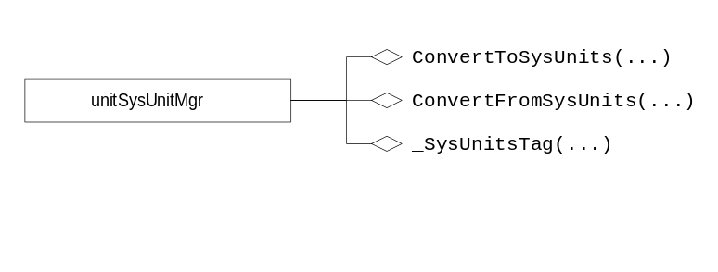
Figure 4

Dynamic Models
N/A

Physical Design
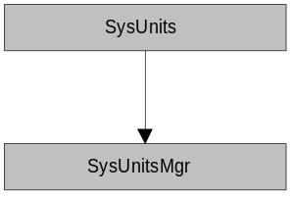
Figure 5
Component | Classes in Component
SysUnitsMgr | unitSysUnitsMgr
SysUnits | ConvertFromSysUnits<T>  ConvertToSysUnits<T>

Specifications

unitSysUnitsMgr
System Unit manager class. Provides methods to access and modify the internal system units. System units are typically defined at application startup in main().

Public Interface - Member Functions
SetMassUnit
static void SetMassUnit(const unitMass& mu);
Sets the system units for mass to mu.
GetMassUnit
static const unitMass& GetMassUnit() const;
Returns the current system units for mass.
SetLengthUnit
static void SetLengthUnit(const unitLength& lu);
Sets the system units for length to lu.
GetLengthUnit
static const unitLength& GetLengthUnit() const;
Returns the current system units for length.
SetTimeUnit
static void SetTimeUnit(const unitTime& tu);
Sets the system units for time to tu.
GetTimeUnit
static const unitTime& GetTimeUnit() const;
Returns the current system units for time.
SetTemperatureUnit
static void SetTemperatureUnit(const unitTemperature& tu);
Sets the system units for temperature to tu.
GetTemperatureUnit
static const unitTemperature& GetTemperatureUnit() const;
Returns the current system units for temperature.
SetAngleUnit
static void SetAngleUnit(const unitAngle& au);
Sets the system units for angular measure to au.
GetAngleUnit
static const unitAngle& GetAngleUnit() const;
Returns the current system units for angular measure.

Implementation Notes

Initializing Default System Units
The physical unit types are stored as private static data members. In the cpp file, the static members must be initialized to meters, kilograms, seconds, radians, and degrees centigrade.

ConvertFromSysUnits<T>
Template method for converting a value from system units to a specified unit of measure
ConvertFromSysUnits<T>
Float64 ConvertFromSysUnits(Float64 value,const T& to)
Converts value from system units to the unit of measure specified by to. Example: ConvertFromSysUnits(value, unitMeasure::Inch); Converts value from system units for length to inches.

ConvertToSysUnits<T>
Template method for converting a value to system units from a specified unit of measure
ConvertToSysUnits<T>
Float64 ConvertToSysUnits(Float64 value,const T& from)
Converts value to system units from the unit of measure specified by from. Example: ConvertToSysUnits(value, unitMeasure::Inch); Converts value from inches to the system units for length.

_SysUnitTag<T>
Template method for creating a unit tag for based on system units.
_SysUnitTag<T>
std::string _SysUnitTag<T>();
Returns a unit tag for a physical unit type. To make this method more natural to use the following macro is defined
#define SysUnitTag(type) _SysUnitTag<type>

Stationing
It is common in civil engineering projects to represent the distance along an alignment with stations. In traditional English units stations are in hundreds of feet. In SI units stations are in thousands of meters. The stationing services provides a mechanism to represent a length in station format and to convert a station to a floating point number. Stations in English units take for form xxx+yy.zz and stations in SI units take the form xxx+yyy.zzz.

Specifications

unitStationFormat
Converts floating point numbers to and from station format.

Public Interface - Member Functions
unitStationFormat
unitStationFormat();
Default constructor. Initializes the unit of measure to Meter.
unitStationFormat
unitStationFormat(UnitOfMeasure unitOfMeasure);
Default constructor. Initializes the unit of measure to unitOfMeasure.
unitStationFormat
unitStationFormat(const unitStationFormat& rOther);
Copy constructor
~unitStationFormat
~unitStationFormat();
Destructor
operator=
unitStationFormat& operator=(const unitStationFormat& rOther);
Assignment operator
FromString
Float64 FromString(const std::string& station) const;
Returns the station as a floating point number in system units. If station is ill-formed, an unitXStationFormat exception is thrown.
AsString
std::string AsString(Float64 station) const;
Returns a string that represents station in station format.
SetUnitOfMeasure
void SetUnitOfMeasure(UnitOfMeasure unitOfMeasure);
Sets the unit of measure of the station
GetUnitOfMeasure
unitStationFormat::UnitOfMeasure GetUnitOfMeasure() const;
Returns the unit of measure.
IsValidString
bool IsValidString(const std::string& station) const;
Returns true if station is in valid format, otherwise false. If the unit of measure is Meter, the string format is xxx+yyy.zzz. If the unit of meausre is Feet, the string format is xxx+yy.zz.

Public Interface - Enumerations
UnitOfMeasure
enum UnitOfMeasure { Meter, Feet };
Unit of measure modes.

unitXStationFormat
Exception class thrown when a station string is ill-formed.

Public Interface - Member Functions
unitXStationFormat
unitXStationFormat(const unitXStationFormat& rOther);
Copy constructor
GetUnitOfMeasure
unitStationFormat:UnitOfMeasure GetUnitOfMeasure() const;
Returns the unit of measure of the unitStationFormat object that threw this exception.
GetOffendingString
std::string GetOffendingString() const;
Returns the ill-formed station string.

unitStationFormats
Utility class the encapsulates instantiations of unitStationFormat for SI and US units.

Public Interface - Data Member
unitStationFormats
class unitStationFormats
{
public:
static const unitStationFormat SI;
static const unitStationFormat US;
};
The constructors are private so this class cannot be instantiated.

Auto-System Units
When an exceptional condition occurs, it is important to cleanup prior to stack unwinding. The unitAutoSysUnits class provides a simple mechanism to provide automatic cleanup for system units. This class is useful in situations where system units are changed for the scope of a method and then are returned to their original settings. To use this class, simply create an instance of unitAutoSysUnits at the beginning of a method and forget about it. Now matter how the method exists, system units will be restored to their settings prior to this method call.

Specifications

unitAutoSysUnits
A utility class that automatically restores system units.

Public Interface - Member Functions
unitAutoSysUnits
unitAutoSysUnits();
Default constructor. Sets the restore units to the current system units.
unitAutoSysUnits
unitAutoSysUnits(const unitMass& um
const unitLength& ul,
const unitTime& ut,
const unitTemperature& uk,
const unitAngle& ua);
Constructor. Sets the restore units to the supplied values.
unitAutoSysUnits
unitAutoSysUnits(const unitAutoSysUnits& rOther);
Copy constructor.
~unitAutoSysUnits
virtual ~unitAutoSysUnits();
Destructor
operator=
unitAutoSysUnits& operator=(const unitAutoSysUnits& rOther);
Assignment operator.
SetMassUnit
void SetMassUnit(const unitMass& u);
Sets the unit of measure for mass that the system units will be set to when this object is destroyed.
SetLengthUnit
void SetLengthUnit(const unitLength& u);
Sets the unit of measure for length that the system units will be set to when this object is destroyed.
SetTimeUnit
void SetTimeUnit(const unitTime& u);
Sets the unit of measure for time that the system units will be set to when this object is destroyed.
SetTemperatureUnit
void SetTemperatureUnit(const unitTemperature& u);
Sets the unit of measure for temperature that the system units will be set to when this object is destroyed.
SetAngleUnit
void SetAngleUnit(const unitAngle& u);
Sets the unit of measure for angle that the system units will be set to when this object is destroyed.

